**Database design document**

Name:韦泽晟

Student ID:201830570323

Class:计创二班

**1.We use the following sql commands to create the tables:**

CREATE DATABASE MDB;

go

use MDB

CREATE TABLE Student (

SID varchar(10) NOT NULL ,

Sname nvarchar(10) NOT NULL ,

Sex nvarchar(5) check(sex='男' or sex='女') NOT NULL,

SchoolAge int check(Schoolage > 10 and Schoolage < 50) NOT NULL ,

SchoolYear int NOT NULL ,

Class nvarchar(20) NOT NULL ,

primary key(SID)

)

CREATE TABLE Course (

CID varchar(7) NOT NULL ,

Cname nvarchar(10) NOT NULL ,

TID varchar(5) NOT NULL ,

Credit int NOT NULL ,

Grade varchar(30) NOT NULL ,

CancelYear int NULL ,

primary key(CID)

)

CREATE TABLE Teacher (

TID varchar(5) NOT NULL ,

Tname nvarchar(10) NOT NULL ,

Course nvarchar(10) NOT NULL ,

primary key(TID)

)

CREATE TABLE Choose (

SID varchar(10) NOT NULL,

CID varchar(7) NOT NULL,

TID varchar(5) NOT NULL ,

Score int NULL ,

ChooseYear int NOT NULL ,

foreign key(SID) references Student(SID),

foreign key(CID) references Course(CID),

foreign key(TID) references Teacher(TID)

)

CREATE TABLE Permission1 (

SID varchar(10) NOT NULL ,

SPW varchar(10) NOT NULL ,

primary key(SID)

)

CREATE TABLE Permission2 (

TID varchar(5) NOT NULL ,

TPW varchar(10) NOT NULL ,

primary key(TID)

)

CREATE TABLE Permission3 (

MID varchar(7) NOT NULL ,

MPW varchar(10) NOT NULL ,

primary key(MID)

)

**2.And the tables are shown as following:**

**Table”Choose”:**

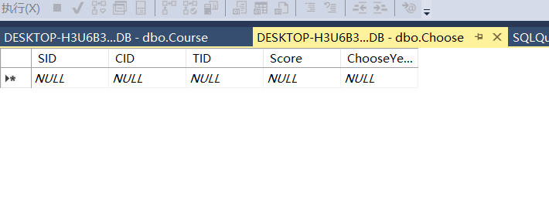

**Table”Course”:**

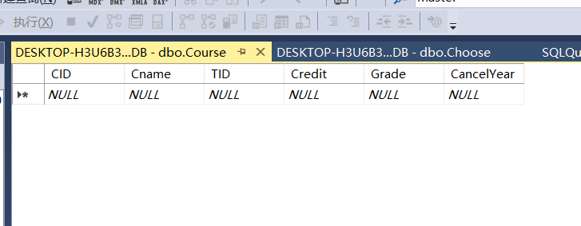

**Table”Permission1”:**

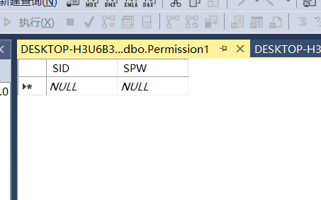

**Table”Permission2”:**

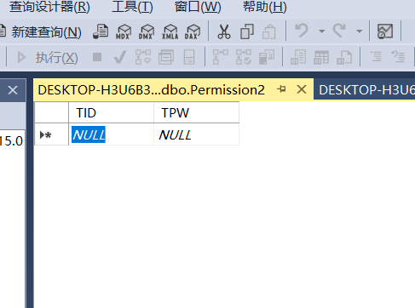

**Table”Permission3”:**

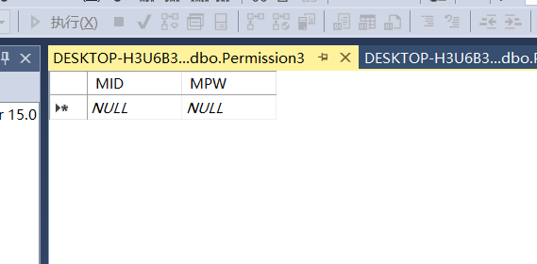

**Table”Student”:**

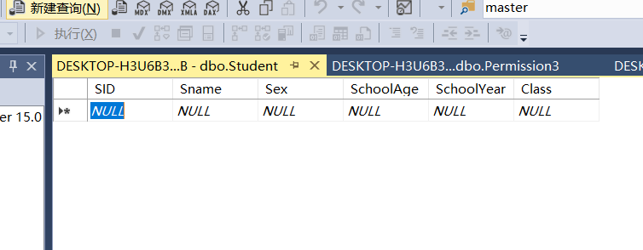

**Table”Teacher”:**

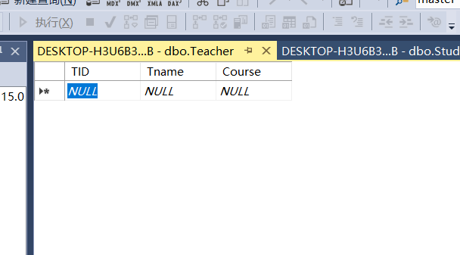

**3.Then I add the following data into the database MDB:**

use MDB;

alter table choose NOCHECK constraint all;

alter table student NOCHECK constraint all;

alter table course NOCHECK constraint all;

alter table teacher NOCHECK constraint all;

alter table choose DISABLE trigger all;

alter table student DISABLE trigger all;

alter table course DISABLE trigger all;

alter table teacher DISABLE trigger all;

insert into Student values('1561401613',N'毛挺','男','18','2015',N'计联');

insert into Student values('1530561331',N'谈力','男','18','2015',N'计联');

insert into Student values('1530501085',N'晁阳','男','19','2015',N'计联');

insert into Student values('1530591376',N'韩梅梅','女','17','2015',N'计科');

insert into Course values('1008060',N'算法','10001',2,'2','2019');

insert into Course values('1203006',N'计组','10003',1,'2','2018');

insert into Course values('3009405',N'java','20010',2,'1','2020');

insert into Course values('7787564',N'经济学','35790',1,'1','2020');

insert into Teacher values('10001',N'颜老师',N'算法');

insert into Teacher values('10003',N'毛老师',N'计组');

insert into Teacher values('20010',N'张老师',N'java');

insert into Teacher values('35790',N'田老师',N'经济学');

insert into Choose values('1561401613','1008060','10001',95,null);

insert into Choose values('1561401613','1203006','10003',92,null);

insert into Choose values('1561401613','3009405','20010',94,null);

insert into Choose values('1530561331','1008060','10001',96,null);

insert into Choose values('1530561331','1203006','10003',88,null);

insert into Choose values('1530591376','1203006','10003',94,null);

insert into Choose values('1530591376','3009405','20010',92,null);

insert into Permission1 values('1561401613','111111');

insert into Permission1 values('1530561331','222222');

insert into Permission1 values('1530501085','333333');

insert into Permission1 values('1530591376','444444');

insert into Permission2 values('10001','555555');

insert into Permission2 values('10003','666666');

insert into Permission2 values('30405','777777');

insert into Permission2 values('35790','888888');

insert into Permission3 values('24680','100000');

select * from choose;

select * from Student;

select * from Teacher;

select * from Course;

select * from Permission1;

select * from Permission2;

select * from Permission3;

**4.Finally,The tables after added are shown as following:**

**Table”Choose”:**

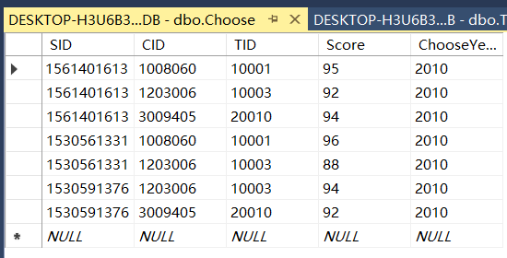

**Table”Course”:**

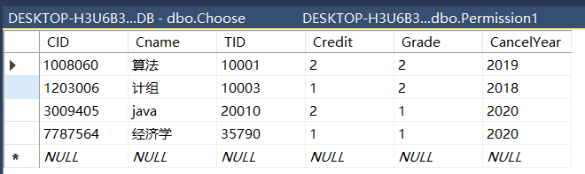

**Table”Permission1”:**

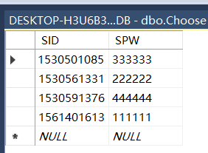

**Table”Permission2”:**

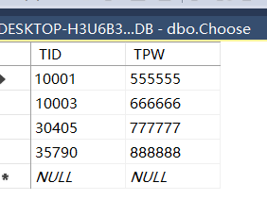

**Table”Permission3”:**

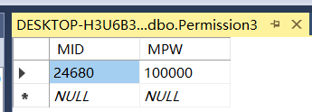

**Table”Student”:**

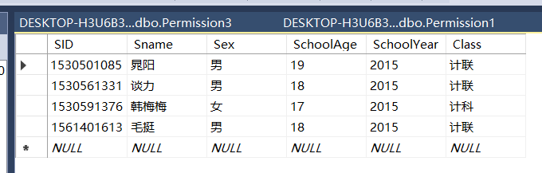

**Table”Teacher”:**

